Weather Study Guide Name_________________________________________
Fill in the blank.
Weather is constantly changing. It is measured using different instruments.
A meteorologist forecasts or predicts the weather using data collected from these instruments. Air moves from high(H) to low(L) pressure creating winds.
Match with the correct word/picture pair.
An anemometer measures wind speed. | 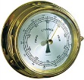 | barometer
A thermometer measures temperature.
 | 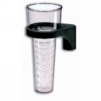 | rain gauge
A barometer measures air pressure.
 | 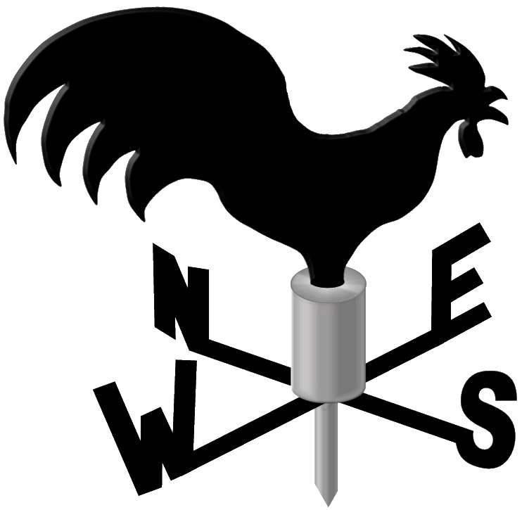 | wind vane
A wind vane measures wind direction.
 | 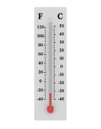 | thermometer
A rain gauge measures amount of precipitation.
 | 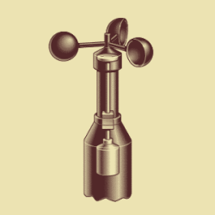 | anemometer
Complete the tree map on clouds. Cloud Types

cirrus cumulus stratus nimbus
thin puffy flat joins other clouds
Precipitation
Cumulonimbus = thunderstorms
gray
Gray sheet
Fog/low
drizzle
White, fluffy
“cotton”
Nice/fair weather
Wisp of hair
Ice crystals
High in sky
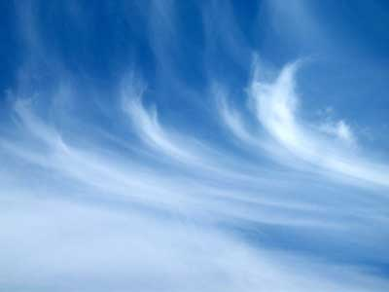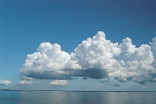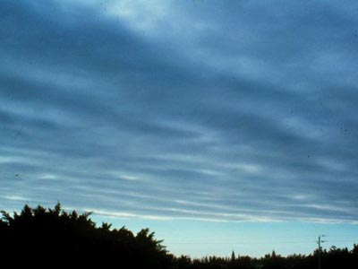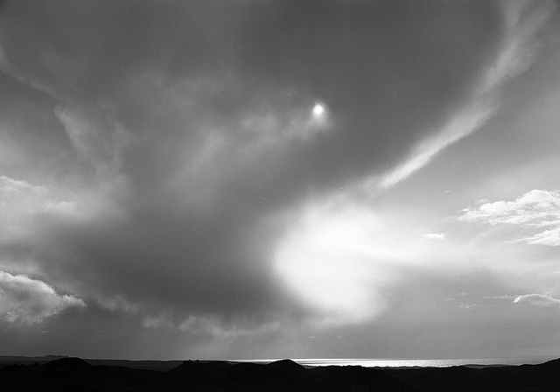

Complete the Water Cycle flow map.
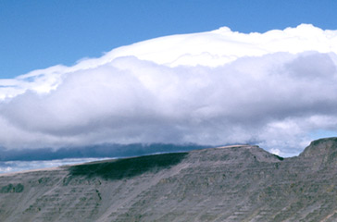
Condensation
water cools off and sticks together to form clouds

precipitation
a cloud becomes saturated and it must let the water go, temperature determines the type
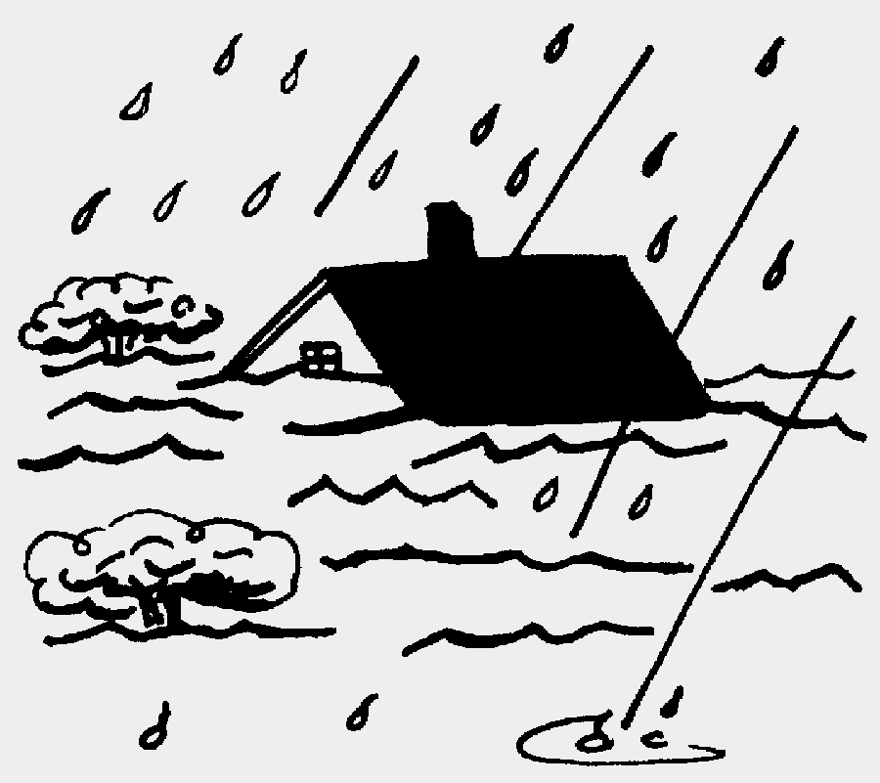
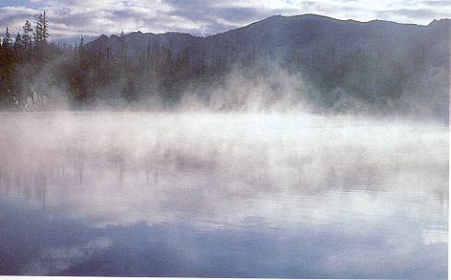
evaporation
water is heated and forms water vapor (water is in gas form)

Runoff
collection
water runs-off of landforms or seeps through the ground, into streams, rivers, lakes, oceans
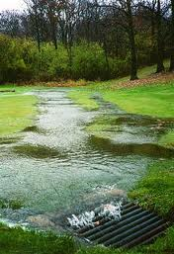

Fill in the blank.
The sun’s energy is the driving force of the water cycle.
Transpiration is the evaporation of water that has come through the leaves of plants.
Fronts are boundaries between 2 air masses different temperature.
When these air masses have different temperatures and cause a front, thunderstorms often occur.

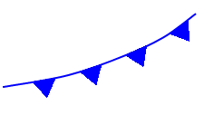
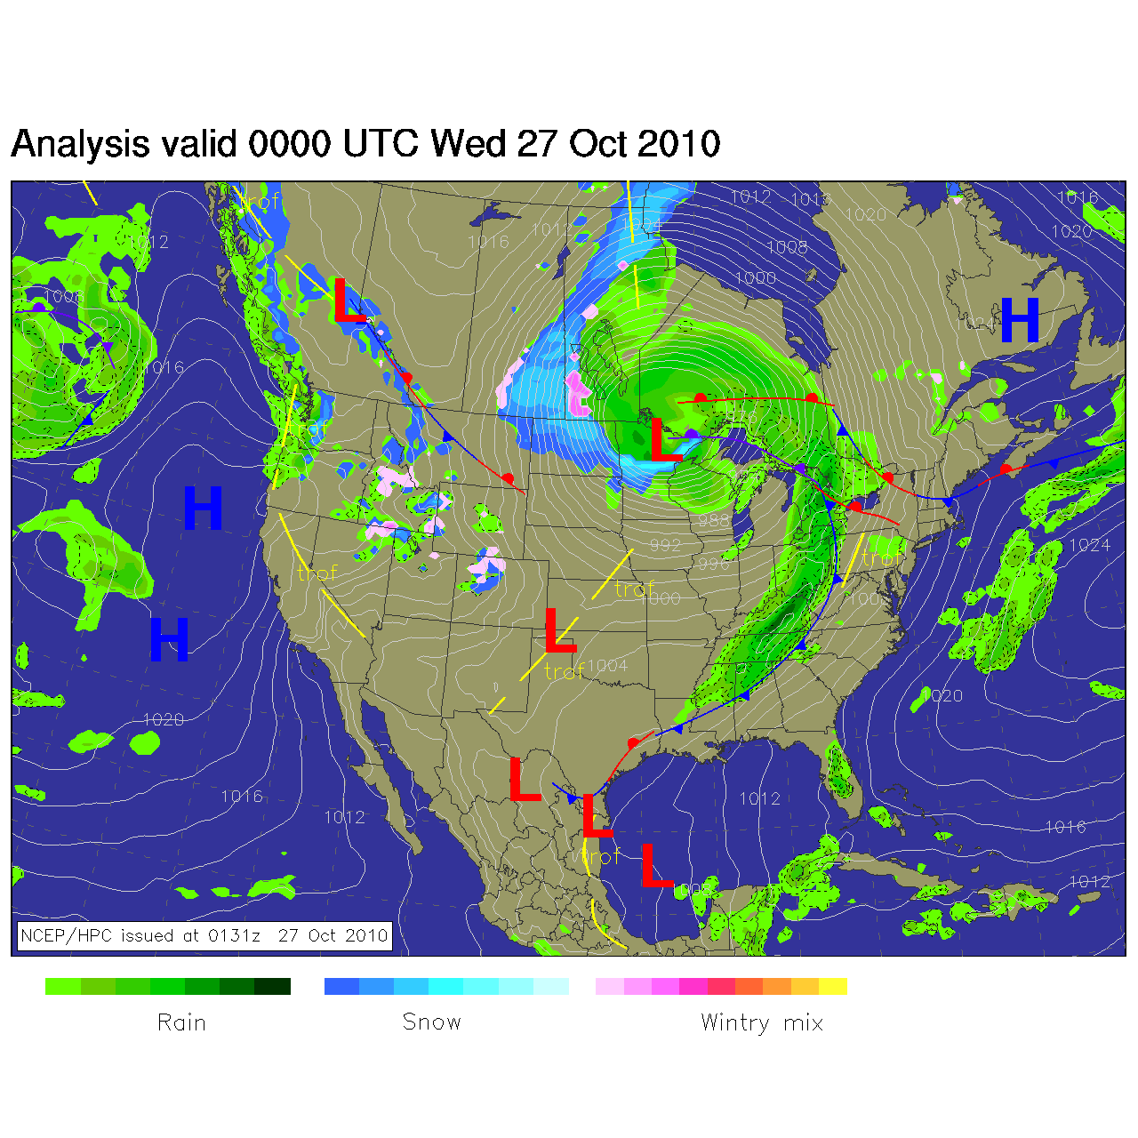
Cold fronts occur when cold air replaces warmer air and often
Produce severe weather .

Warm fronts occur when warm air replaces cooler air and often brings fog.
Using the weather map, answer the questions.
What area is currently in a Low pressure system?
Midwest of US, west of Canada, East in Mexico, Gulf of Mexico
What area is getting the most precipitation?
West of NC and up through Canada, above Great Lakes
Why is there a cold front at the leading edge of the rain moving into North Carolina?
Because a cold front brings storms where the cold air takes place of warm air
Causes convection—big temperature difference

