TEACHER DIRECTIONS
Cut up codes and put them around your room. Have students make groups of 3-4. Need one scanner, recorder, and a researcher in each group. Scanner will use iPad to scan QR codes around room. Recorder will record answer on Google Form. Researcher will look up answers in Handbook. I will send you the google form. We can do it all to one. There is a QR code for the Form included at the bottom. ONLY THE RECORDER NEEDS TO SCAN THIS, then they need to hit the send to button and OPEN IN SAFARI or the form will not submit when they are done. There will not be a way for them to look back at the answers at the end so you can just pull up the spreadsheet and go over it. I included the ?s here to help you out. If I put the ?# on the QR code scan to help too. It will be easier if we do it in one and then I can sort it later and pull our your students. Teacher name is one question. ENJOY!
Student Handbook Scavenger Hunt
- What is our Principal’s name?
- What time does our school day officially begin?
- What time does our school day end?
- Who is Mr. Longest?
- What should your parent do if you are to go home a different way than normal?
- When are weekly folders sent home?
- What are the 3 school expectations?
- How much are school fees?
- What is your teacher’s name? (the most awesome teacher in the world…ha ha )
- What are SGE’s school uniform shirt colors?
- List 5 offenses that would result in an automatic referral to the office.
- What is the charge for lost student planner?
- What is the cost of a paid lunch? (full price)
- What is the earliest any student should arrive at school?
- What is the address of our school?
- What should a parent do if they want to visit/volunteer in your classroom?
- ***BONUS*** What iPad apps are you using right now to complete this activity?
- ***BONUS*** What are these special codes called that you are scanning?
- ***BONUS*** Which iPad app do you use to access the internet?
- What are the names of the collaborators in your group for this activity?

Question 1 Question 2

Question 3 Question 4

Question 5 Question 6

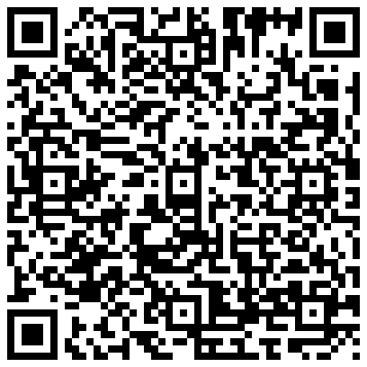

Question 7 Question 8

Question 9 Question 10

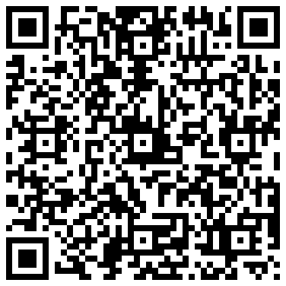

Question 11 Question 12

Question 13 Question 14

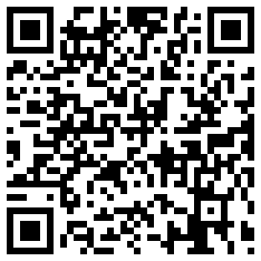

Question 15 Question 16

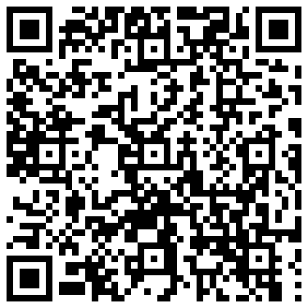

Question 17 Question 18

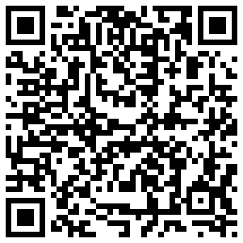

Question 19 Question 20

Answer Form Code for Recorder ****after scanning, tap “send to “ button then OPEN IN SAFARI****

