Genetics Study Guide 5th grade Science Unit Name____answer key______ Teacher Initial & Class #___D1____
Match the vocabulary words by writing the correct letter for the word on the line.
A. learned trait B. inherited trait C. offspring D. parent E. genes F. organism
G. population H. trait I. dominant trait J. recessive trait K. natural selection L. classify
__F_ any living thing ___ D __ a plant or animal that produces offspring

__ H __ a special quality or characteristic that makes you different ___ B __ a characteristic that is passed on to offspring from a
from others parent

__ A ___ a characteristic that is gained by knowledge or experience ___ I __ a trait that always shows over others

__ G ___ a group of one or more species or organisms living in a particular ___ E __ tiny part of DNA that is passed on to offspring from a
area or habitat parent and influences inherited traits

__ C ___ the young of a person, animal or plant __ J ___ a trait that is masked by a dominant trait and is not shown unless an offspring receives only recessive genes

__ K___a form of evolution that allows animals/plants to adapt to their __ L ___ to put plants and animal into certain groups based on
environment to be able to be more likely to survive their characteristics
List examples of traits/behviors
Learned Traits and Behaviors versus Inherited Traits and Behaviors
-learned traits are acquired or gained by -inherited traits are passed on to offspring and they are
knowledge or experience things you are born knowing how to do(innate)

answers may vary depending on student answers may vary depending on student
riding a bike eye color
playing the violin natural hair color and straight or curly hair
liking a certain color ability to roll your tongue
liking or not liking certain foods breathing
dyed hair color sleeping

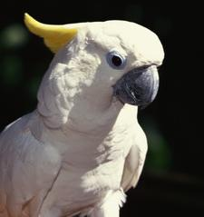 | This cockatoo has white feathers. This is an example of a(n) _inherited_____ trait.  Joe taught his cockatoo how to speak English. This is an example of a(n) _______ learned______________________trait.  The cockatoos may eat orange bugs and not green ones that blend in with plant leaves. This is ___natural  selection.

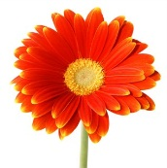 | Greg has a beautiful garden. This year he had one orange daisy come up. If he saved the seeds from this daisy and planting  them to grow next spring/summer, what color do you expect the new daisy to be? orange
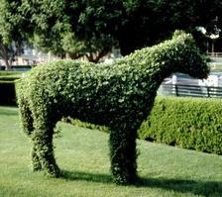 | Keisha likes to cut her shrubs into shapes. Which of the following is an inherited trait of the shrub?  - The shrub is shaped like a cow. B. The shrub is in Kesha’s garden. C. The shrub has green leaves.
Natural Selection: Write in either white or black peppered moths

Which moths survived better on the trees covered with lichens which made them appear white? __ white peppered________

Which moths survived better on the trees after they were covered with soot from all of the factories?____ black peppered___________

In natural selection, why does one variation of a trait have a better chance of survival over another? One variation is more hidden by the environment and less likely to be chosen as food and therefore has a higher chance of survival
Classifying Plants and Animals:

What do scientists use to classify plants and animals? traits and characteristics

_____ Mammals__ are a group of animals that usually have hair or fur. Examples: __ humans___, ____ whales______, __ dogs____

_Insects_____ have six legs. Examples: fly, bee, ant, cockroach
Arachnids have eight legs like the spider. Examples: brown recluse, black widow, granddaddy longlegs
Some animals have a ___ backbone______ or a spine like humans, others like insects have an ___ exoskeleton_ or hard
outer shell that help them hold their shape and some are soft all over like _____ jellyfish_.

